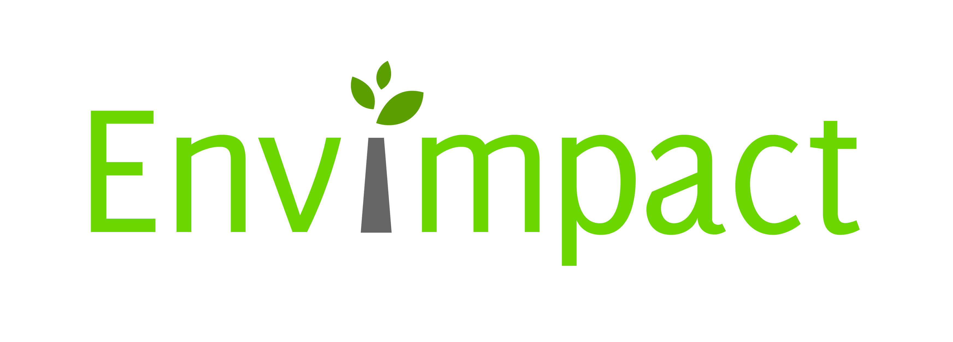
Increasing the impact of Central-Eastern European environment research results through more effective dissemination and exploitation
Project No: 265275

Registration form for e-mentoring

name of the participant | e-mail addresse of the participant | institute of the participant | topic and date of the e-mentoring (with trainer’s name) | questions to the trainer

